Setting the Exakta shutter
Short or very long (B or T/Z) exposure times
Cock the shutter and set the short times knob on
(Don't wind the long time mechanism: If you do, it will unwind uselessly)
- the required time for short times
- B for press-to-open > let-go-to-shut
- T/Z for press-and-let-go-to-open > press-and-let-go-to shut
Long exposure times
Cock the shutter, wind the long time mechanism, set the short times knob on
B or T/Z and select a long time (one of the black settings) on the long times knob. Releasing
now will produce the chosen long time. Maximum exposure 12 seconds.
- 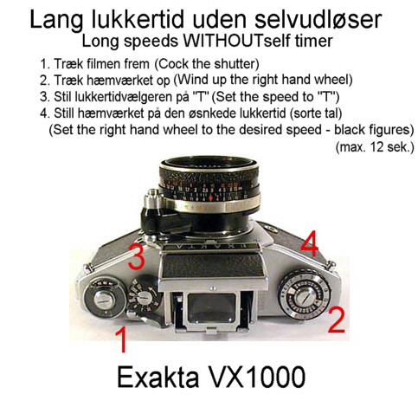
- Short exposure times with self timer
Cock the shutter, wind the long time mechanism, choose a short time on the
short times knob, set the long times mechanism on any red time.
Releasing now will produce a short exposure time with self timer.
Long exposure times with self timer
Cock the shutter, wind the long times mechanism. set the short times knob on
B or T/Z, select a time-with-self timer (one of the red settings).
Releasing will now produce a long exposure time with self timer. Maximum 6
seconds exposure.
- 